A Special General Meeting will be held at 2.00pm on Saturday,
12th December 2020 using Zoom Conferencing

AGENDA

- Apologies:

- Opening Statement by the Chairman, David Edge.

- Closure of The Heather Society as a charity, by year end 2020.

  - Status of The Heather Society funds.
  - Transfer of Intellectual Property from The Heather Society to Heather Society.

- Future of the society as a not-for-profit Unincorporated Association known as the “Heather Society”.

- Closing remarks by the Chairman, David Edge

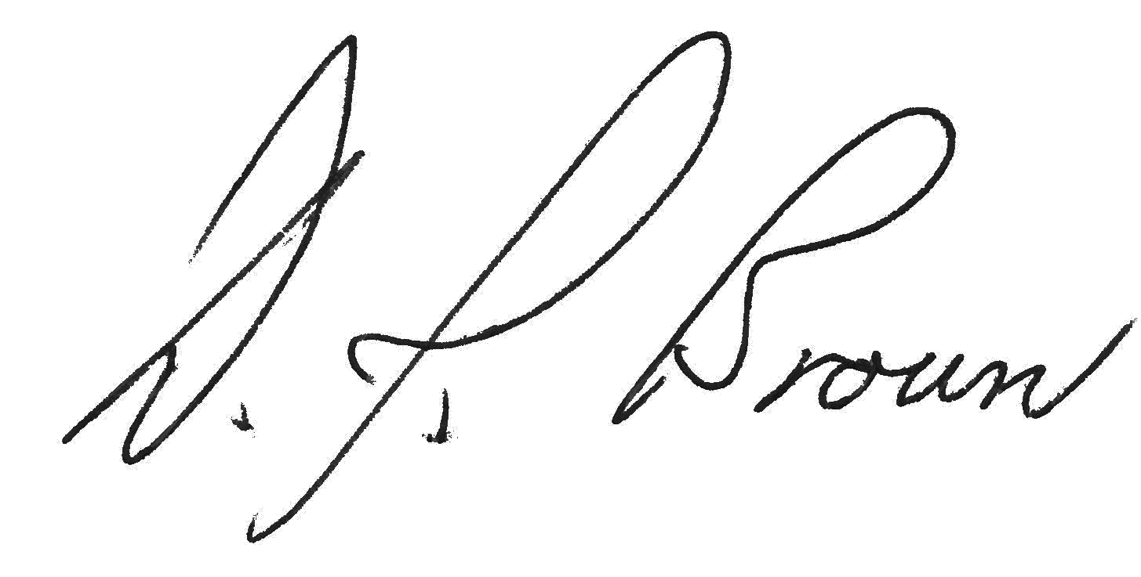

Hon. Secretary 10th December2020

